Stage 4 ★★
Mixed Selection 1 - Solutions

- Quarters
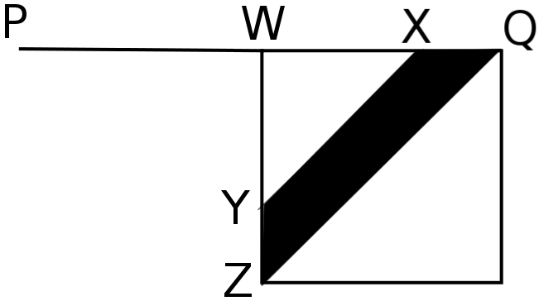
The diagram shows the top-right-hand portion of the square.
The shaded trapezium is labelled QXYZ and W is the point at which ZY produced meets PQ. As QXYZ is an isosceles trapezium, ∠QZY = ∠ZQX = 45°.
Also, as YX is parallel to ZQ, ∠XYW = ∠WXY = 45°. So WYX and WZQ are both isosceles right-angled triangles. As ∠ZWQ = 90° and Z is at centre of square PQRS, we deduce that W is the midpoint of PQ. Hence WX = XQ = PQ/4. So the ratio of the side-lengths of similar triangles WYX and WZQ is 1:2 and hence the ratio of their areas 1:4.
Therefore, the area of trapezium QXYZ = $\frac{3}{4}$ x area of triangle ZWQ = $\frac{3}{32}$ x area PQRS since triangle ZWQ is one-eighth of PQRS. So the fraction of the square which is shaded is 4 x $\frac{3}{32}$ = $\frac{3}{8}$.

- Angle to chord
Let O be the centre of the circle. Then $∠POR=90°$ as the angle subtended by an arc at the centre of a circle is twice the angle subtended by that arc at a point on the circumference of the circle.
So triangle $POR$ is an isosceles right-angled triangle with $PO=RO=4\text{cm}$. Let the length of $PR$ be $x$ cm.
Then, by Pythagoras' Theorem, $x^{2}=4^{2}+4^{2}=2×4^{2}$ and so $x=4√2$

- Diagonal touch
Let $x$and $y$ be the distances shown.
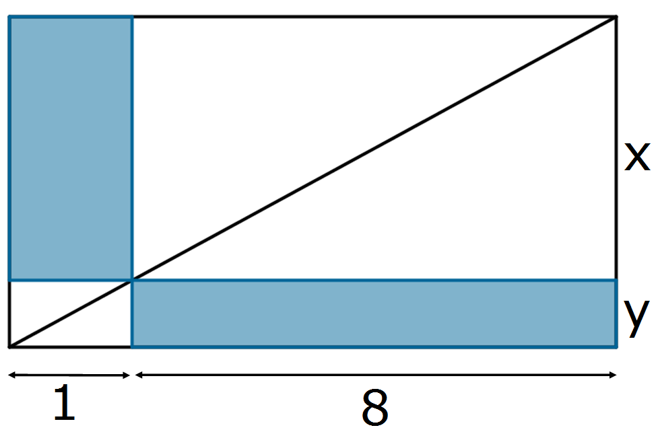
Then the shaded area is $8y+x$. But there are a number of similar triangles and from one pair
$\frac{x}{8}=\frac{y}{1}$ therefore $x=8y$.
So,
$$\frac{shaded area}{total area}=\frac{8y+x}{9\left(x+y\right)}=\frac{8y+8y}{9}×9y=\frac{16}{81}$$

- Isosceles reduction
Triangles $PRS$ and $QPR$ are similar because $∠PSR=∠QRP$ (since $PR=PS$) and $∠PRS=∠QPR$ (since $QP=QR$).
Hence $\frac{SR}{RP}=\frac{RP}{PQ}$, that is $\frac{SR}{6}=\frac{6}{9}$, that is $SR=4$.

